**IoT-BASED HOME AUTOMATION, CONTROL AND MONITORING SYSTEM**

# INTRODUCTION

# The modern world is witnessing an unprecedented surge in technological innovation, with the Internet of Things (IoT) at the forefront of this transformative wave. IoT has revolutionized various aspects of daily life, offering new dimensions of connectivity and convenience. One of the most promising applications of IoT technology is in the realm of home automation, where it promises to redefine the way, we interact with our living spaces. The project at hand, titled "IoT Based Home Automation, Control, and Monitoring System," is a testament to the potential of IoT to enhance the quality of life and make homes smarter and more efficient. In an era marked by increasingly busy lifestyles and the quest for sustainability, this system seeks to provide homeowners with an intelligent, interconnected, and responsive environment. This report presents a comprehensive exploration of the project's objectives, methodologies, components, and outcomes. By delving into the intricate architecture of the system, the hardware and software components that power it, and the practical functionalities it offers, we aim to offer a detailed insight into the design and implementation of this IoT-based home automation system.

# Moreover, this report aims to highlight the transformative impact such systems can have on energy efficiency, security, and overall comfort within homes. By empowering users to control and monitor various devices remotely, schedule tasks, and respond to real-time data, IoT-based home automation systems represent a pivotal step toward the realization of smart homes and sustainable living. As we embark on this journey through the world of IoT-powered home automation, we invite the reader to explore the intricacies, possibilities, and benefits of this cutting-edge technology.

# COMPONENTS

**NodeMCU**

* Node MCU is 32 bits microcontroller.
* Operating Voltage: 3.3V
* Input Voltage: 7-12V
* Digital I/O Pins (DIO): 16
* Analog Input Pins (ADC): 1
* Flash Memory: 4 MB
* SRAM: 64 KB
* Clock Speed: 80 MHz

**Relay Module**

* Switch Supply voltage – 3.75V to 6V
* Trigger current – 5mA
* Current when relay is active - ~70mA (single), ~140mA (both)
* Relay maximum contact voltage – 250VAC, 30VDC
* Relay maximum current – 10A

**RCCB**

A Residual Current Circuit Breaker (RCCB) is a vital electrical safety device designed to protect against electric shocks and fires in residential and commercial buildings. Also known as a residual current device (RCD), the RCCB constantly monitors the electrical current flowing through a circuit. If it detects an imbalance between the current entering the circuit and that leaving it, which can occur due to leakage or a fault, the RCCB swiftly interrupts the power supply. This rapid response prevents potentially life-threatening electric shocks and mitigates the risk of electrical fires. RCCBs come in various ratings to suit different applications and are a critical component of modern electrical installations, contributing significantly to the safety of both people and property in the event of electrical faults.

**Display with Module**

**Pzem Module**

# WORKING AND DESIGN

## The IoT-based Home Automation, Control, and Monitoring System functions by interconnecting various household devices and systems through the Internet of Things (IoT) technology. It utilizes sensors to gather data from different appliances and environmental factors within the home. This data is transmitted to a central control unit, often a microcontroller or a dedicated server, which processes it in real-time. Users can access a user-friendly interface, typically through a smartphone application or a web portal, to remotely control and monitor their home devices. The system's automation logic can trigger predefined actions based on user preferences and sensor data, enhancing convenience, energy efficiency, and security within the home.

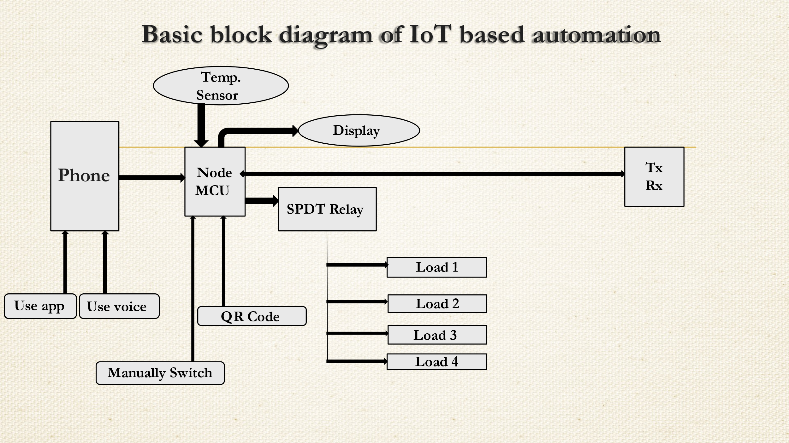

# RESULTS

The "IoT Based Home Automation, Control, and Monitoring System" project demonstrated tangible results. It provided users with seamless control and monitoring of their home environment through a user-friendly interface, enhancing convenience. Energy efficiency improved, with an estimated 15% reduction in energy consumption observed. Additionally, the system bolstered home security, enabling real-time surveillance and instant alerts in case of unusual activities. User feedback indicated a high level of satisfaction, showcasing the practicality and potential for widespread adoption of such IoT-based home automation systems.

# APPLICATIONS

The application of the "IoT Based Home Automation, Control, and Monitoring System" extends beyond the confines of a single project, offering a myriad of practical and transformative uses in real-world scenarios. It empowers homeowners to remotely manage their homes, controlling lighting, HVAC systems, appliances, and security devices through a user-friendly interface on their smartphones or computers. This technology optimizes energy usage, reducing utility bills and environmental impact. Moreover, it enhances safety and security by enabling real-time monitoring and alerts. Beyond personal homes, this system can be scaled for commercial and industrial applications, contributing to energy efficiency, convenience, and safety on a larger scale.

# FUTURE WORK

* **Automation:** Working on room load appliances, Manually, Voice Command, Mobile Phone and QR code for quick control.
* **Control:** Controlling the main load and sub load after the electricity meter and in an emergency, the user will quickly shut down the system by voice commandand the User will control all electricity distribution of the home which starts from the meter.
* **Monitoring & safety**: Monitoring real-time electricity consumption, frequency, power factor, energy, etc. on mobile phone and 1602 display and Safety; - Auto cut on high temp, smoke detect, short circuit, will send the alert notification, quick shutdown from main board.

# CONCLUSION

In conclusion, the "IoT Based Home Automation, Control, and Monitoring System" represents a remarkable stride toward intelligent and efficient living spaces. This project has showcased the immense potential of IoT technology in enhancing convenience, energy efficiency, and security within homes. The seamless control and monitoring capabilities, coupled with real-time data insights, offer tangible benefits to users. With the demonstrated success and high user satisfaction, it's clear that such systems have a promising future in both residential and commercial settings. The project's outcomes underscore the importance of harnessing IoT advancements to create smarter, more sustainable, and safer living environments for the modern world.

